**Work Distribution**

The coding exercises were done by both students which in turn were compared, choosing the best implementation, the testing and bug solving was done as a group. Question number 3 was solved together. Both students contributed equally.

**Question 1**

1. **Performance:** 
   * **Test set:** 0.6193
   * **Validation set:** 0.7236

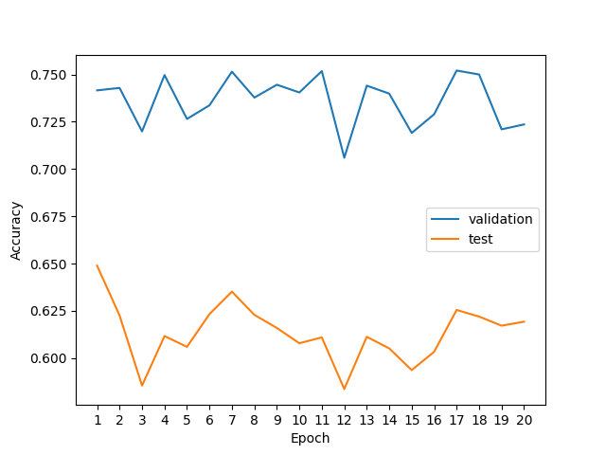

1. **Performance**

* **Test set:** 0.7028
* **Validation set:** 0.8251

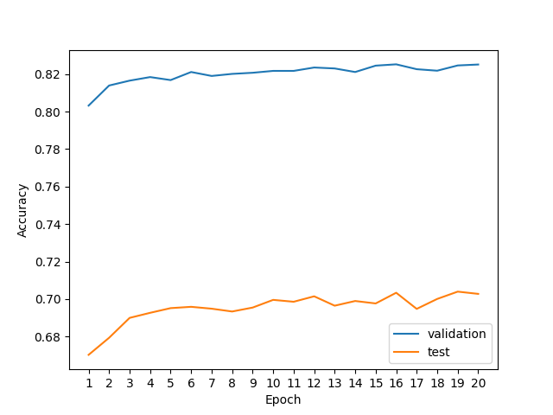

**2.**

**a)** A simple perceptron such as the one implemented in the previous exercise is a model that cannot solve non-linearly separable problems since the VC- dimension of a line is 3 and a single line in 2 dimensions cannot discriminate it.

As opposed to this the multi layered perceptron can solve non-linearly separable problems like XOR.

This is possible because each hidden layer of the perceptron computes a representation of the input and propagates it forward. This in turn will increase the expressive power of the network allowing for more complex, non-linear models.

In case the activation function is linear the multi-layer perceptron will have the same results as the simple perceptron. A multi-layer perceptron with linear activations can be replaced with a simple perceptron by composing those linear activation functions into one linear function.

**b) Performance:**

* **Test set:** 0.8512
* **Validation set:** 0.9307

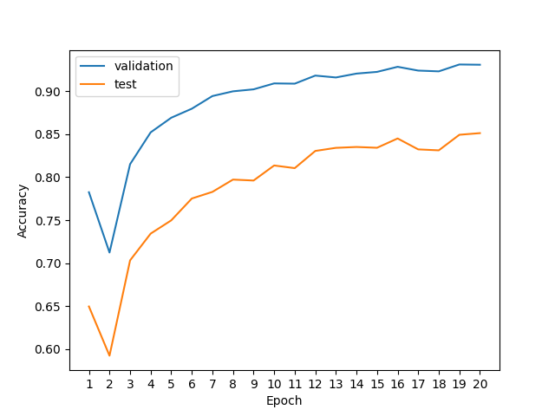

**Question 2**

1. **Best configuration with learning rate** 0.001

**Final Accuracy of test set:** 0.7019

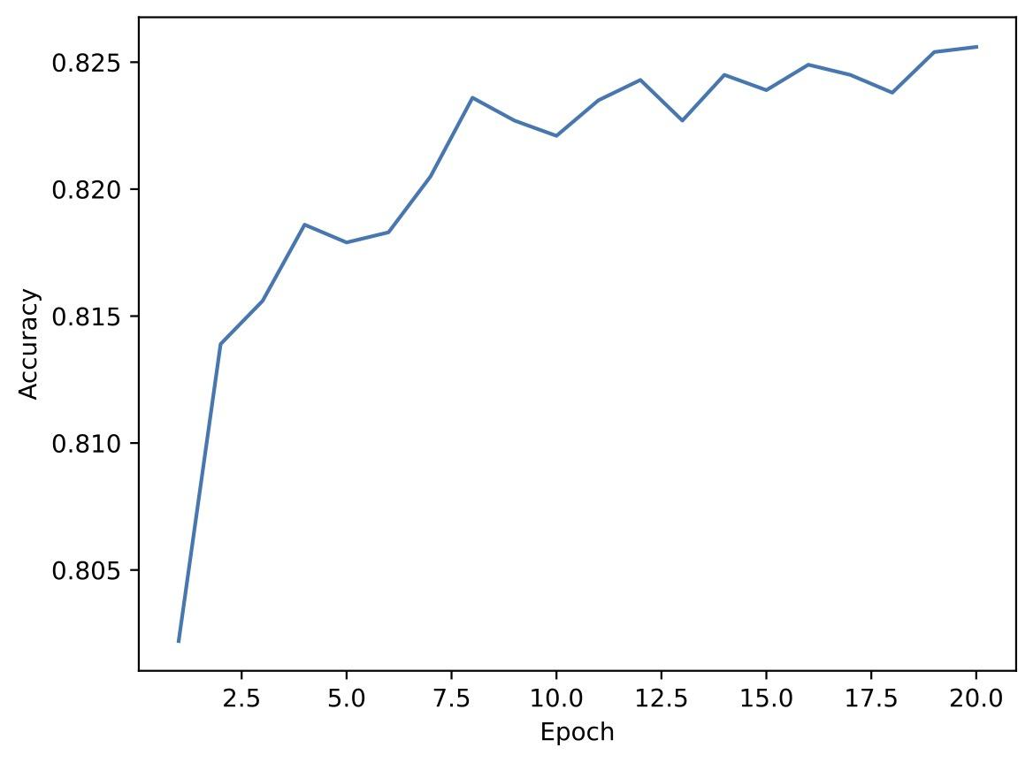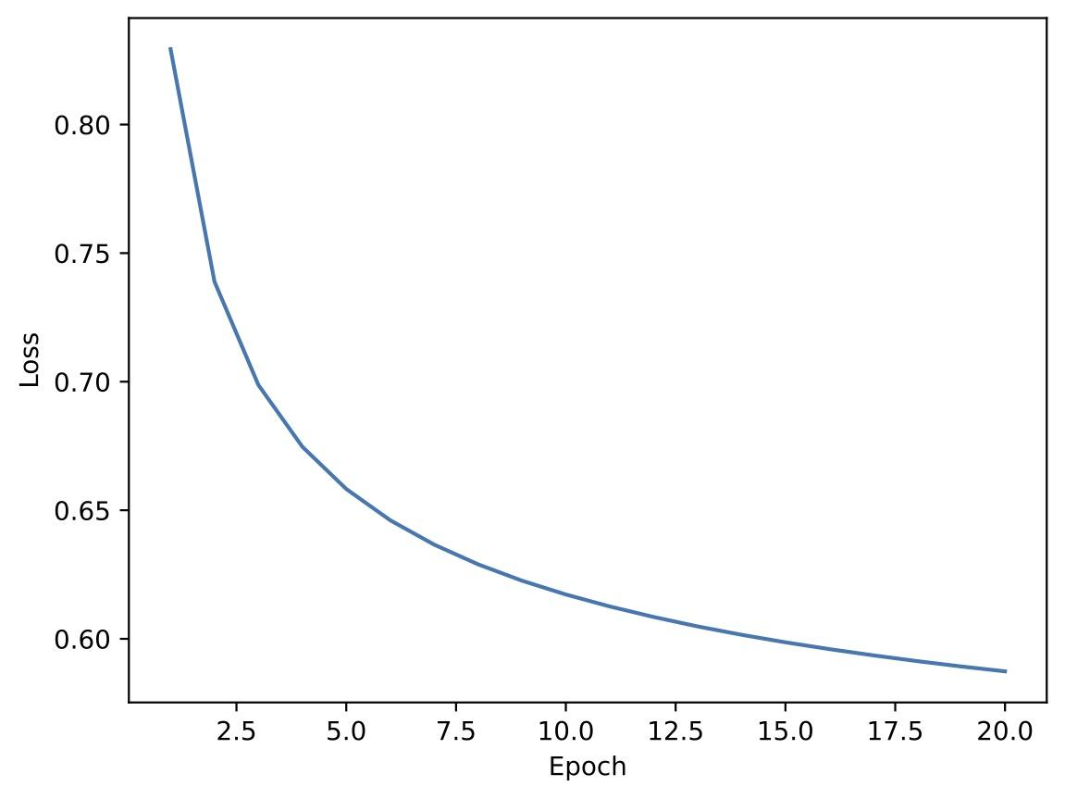

|  |  |
| --- | --- |
| **Best Hyperparameters and Design Choices** | |
| **Learning Rate** | 0.01 |
| **Hidden Size** | 200 |
| **Dropout Probability** | 0.3 |
| **Activation Function** | Relu |

**Final Accuracy of test set:** 0.8953

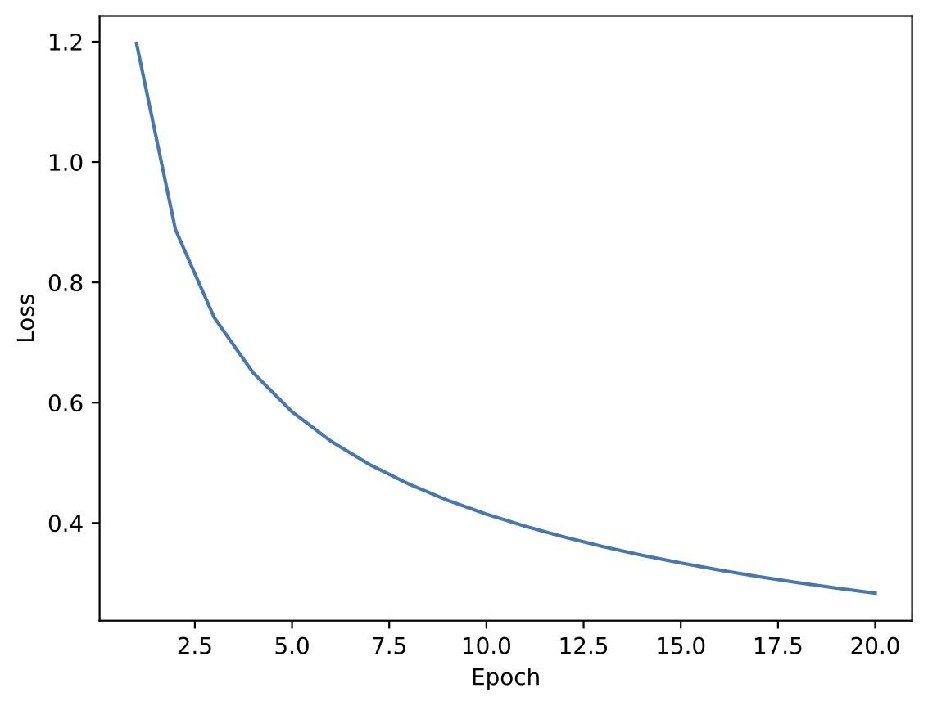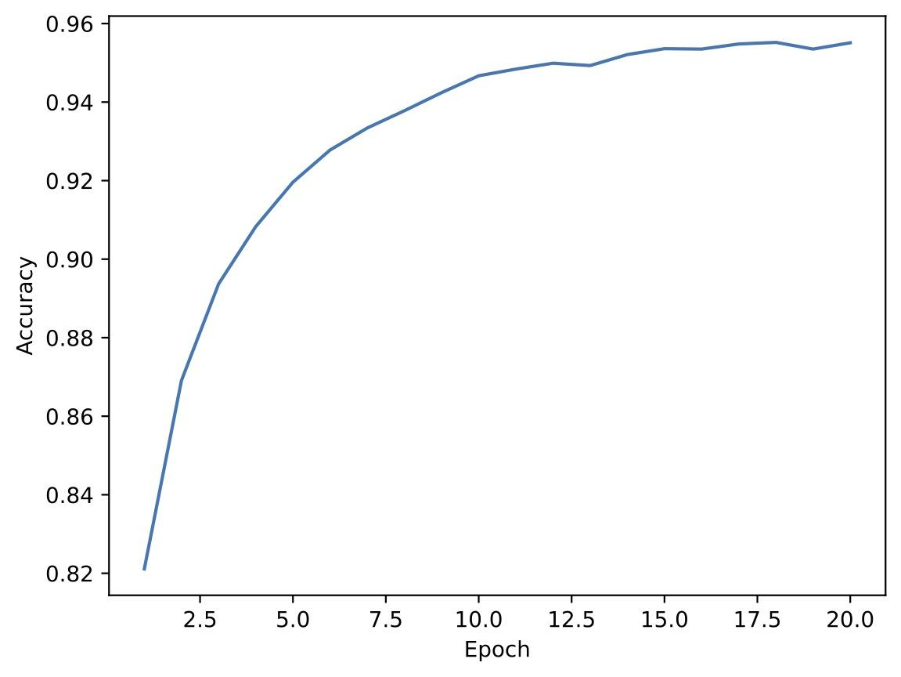

* **With 2 Layers**

**Original Parameters (Shown in the provided table):**

**Final Accuracy of test set: 0.8633**

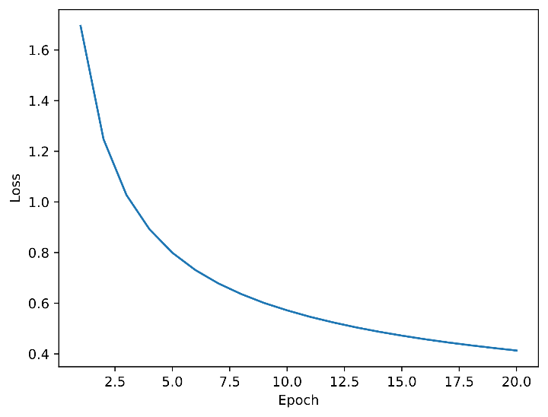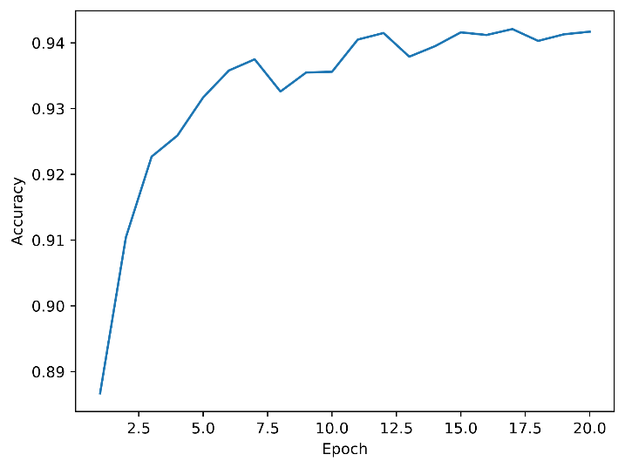

|  |  |
| --- | --- |
| **Best Hyperparameters and Design Choices** | |
| **Learning Rate** | 0.1 |
| **Hidden Size** | 200 |
| **Dropout Probability** | 0.3 |
| **Activation Function** | Relu |

**Final Accuracy of test set:** 0.9011

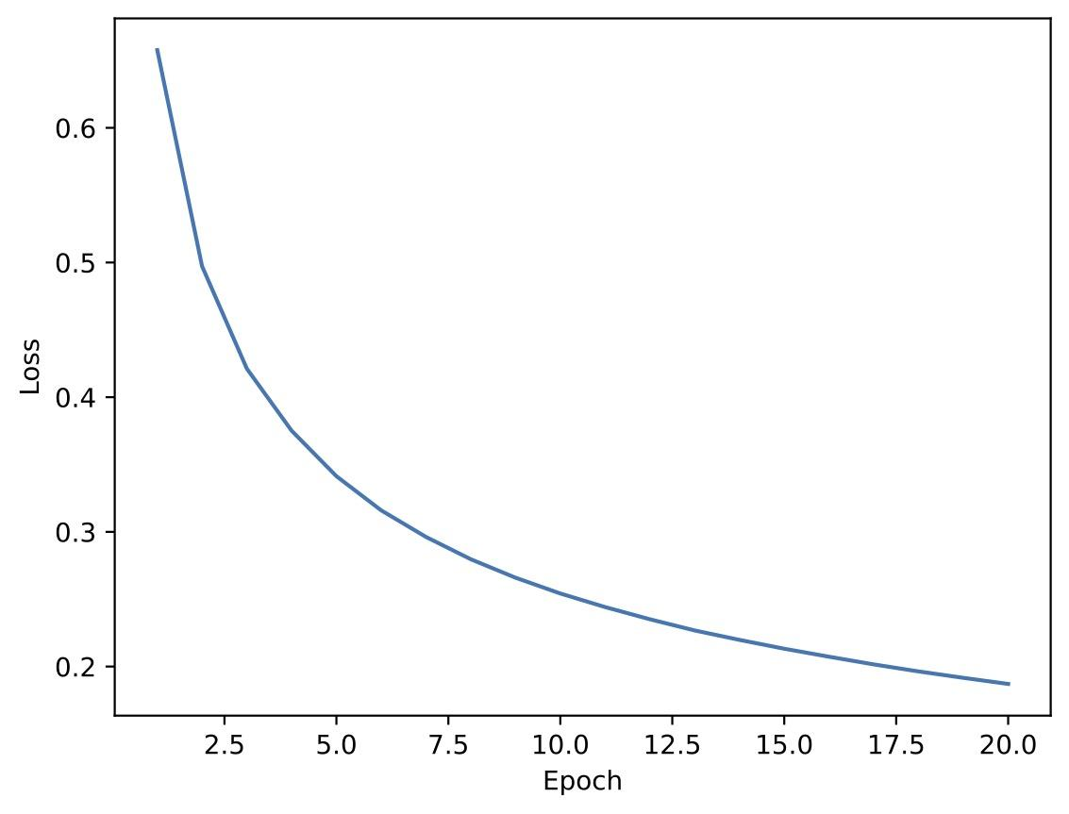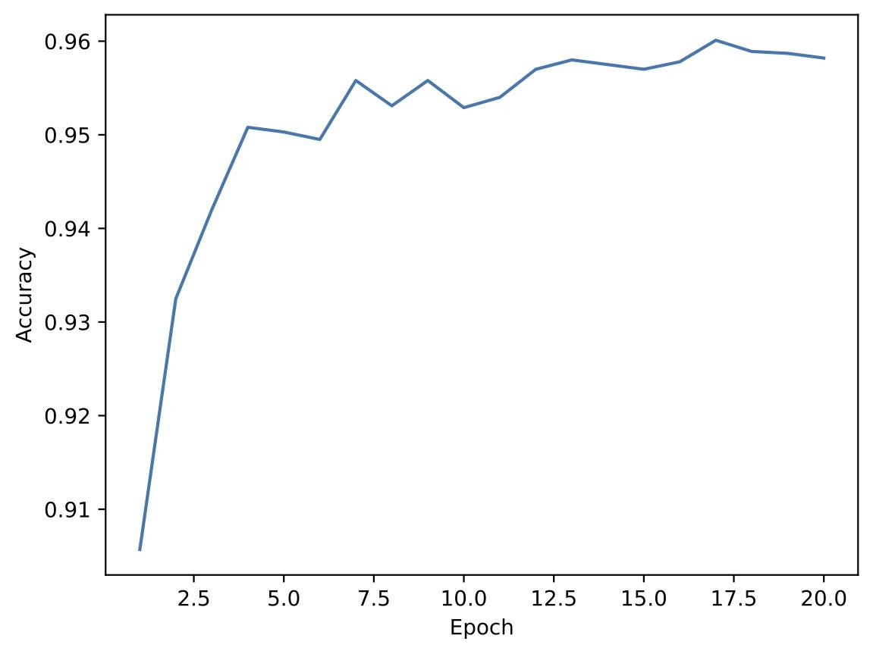

* **With 3 Layers**

**Original Parameters (Shown in the provided table):**

**Final Accuracy of test set: 0.8600**

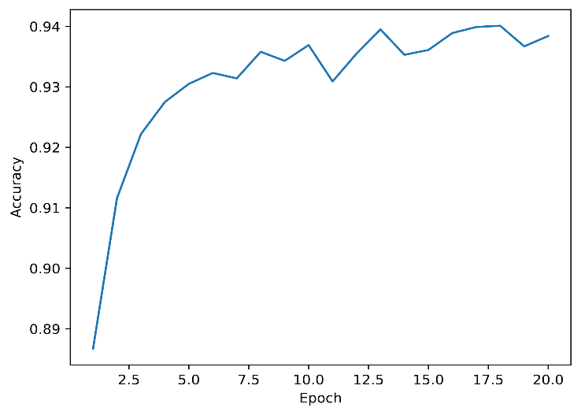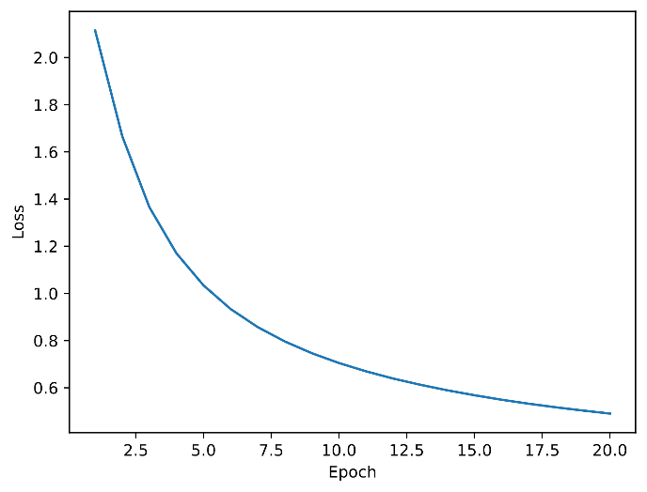

|  |  |
| --- | --- |
| **Best Hyperparameters and Design Choices** | |
| **Learning Rate** | 0.1 |
| **Hidden Size** | 200 |
| **Dropout Probability** | 0.3 |
| **Activation Function** | Relu |

**Final Accuracy of test set:** 0.8990

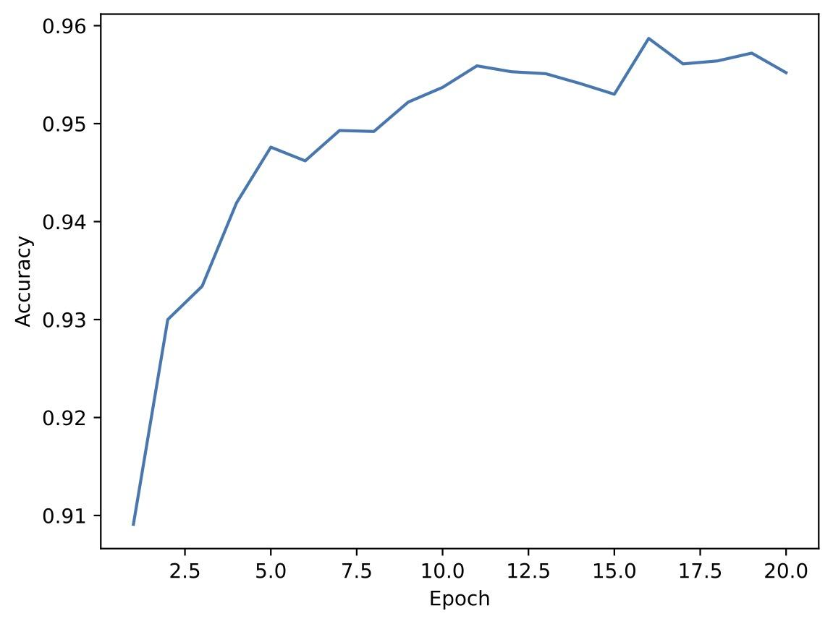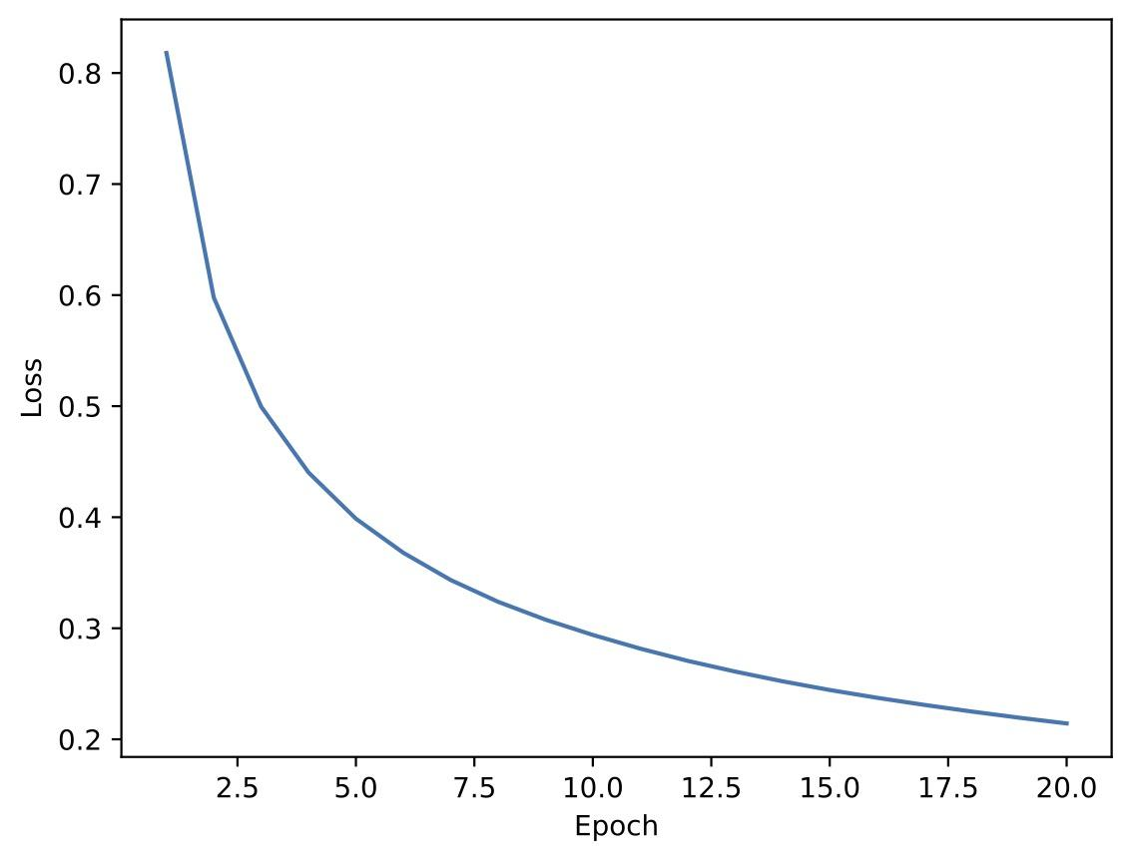

**Question 3**

1. $$h={\left(Wx\right)}^{2} = {\left(\left[\begin{matrix}w_{11} & ⋯ & w_{1D} \\ ⋮ & ⋱ & ⋮ \\ w_{k1} & ⋯ & w_{kD}\end{matrix}\right]\left[\begin{matrix}x_{1} \\ ⋮ \\ x_{D}\end{matrix}\right]\right)}^{2}= {\left(\left[\begin{matrix}\sum_{i=1}^{D}{w_{1i}x_{i}} \\ ⋮ \\ \sum_{i=1}^{D}{w_{ki}x_{i}}\end{matrix}\right]\right)}^{2}= \left(\left[\begin{matrix}\sum_{i=1}^{D}{{\left(w_{1i}x_{i}\right)}^{2}+2\sum_{j=1}^{D}{\sum_{i=1}^{j-1}{\left(w_{1i}x_{i}\right)\left(w_{1j}x_{j}\right)}}} \\ ⋮ \\ \sum_{i=1}^{D}{{\left(w_{ki}x_{i}\right)}^{2}+2\sum_{j=1}^{D}{\sum_{i=1}^{j-1}{\left(w_{ki}x_{i}\right)\left(w_{kj}x_{j}\right)}}}\end{matrix}\right]\right)$$ Considering $d= \frac{D\left(D+1\right)}{2}$, we can say that:

$$h= A_{θ}ϕ\left(x\right)⟺\left[\begin{matrix}a_{11}b_{1}+…+a_{1d}b_{d} \\ ⋮ \\ a_{k1}b_{1}+…+a_{kd}b_{d}\end{matrix}\right]=\left[\begin{matrix}a_{11} & ⋯ & a_{1d} \\ ⋮ & ⋱ & ⋮ \\ a_{k1} & ⋯ & a_{kd}\end{matrix}\right]\left[\begin{matrix}b_{1} \\ ⋮ \\ b_{D}\end{matrix}\right]=\left[\begin{matrix}\sum_{i=1}^{d}{a_{1i}b_{i}} \\ ⋮ \\ \sum_{i=1}^{d}{a_{ki}b_{i}}\end{matrix}\right]$$

Considering the below equation from the first row of the expressions above, we want to know what is $a_{1i}$ and $b_{i}$

$$\sum_{i=1}^{d}{a_{1i}b_{i}}=\sum_{i=1}^{D}{{\left(w_{1i}x_{i}\right)}^{2}+2\sum_{j=1}^{D}{\sum_{i=1}^{j-1}{\left(w_{1i}x_{i}\right)\left(w_{1j}x_{j}\right)}}}=\sum_{i=1}^{D}{{\left(w_{1i}x_{i}\right)}^{2}+2\sum_{j=1}^{D}{\sum_{i=1}^{j-1}{\left(w_{1i}w_{1j}\right)\left(x_{i}x_{j}\right)}}}$$ Therefore, we could consider that

$\sum_{i=1}^{d}{a_{1i}}=\sum_{i=1}^{D}{{\left(w_{1i}\right)}^{2}+2\sum_{j=1}^{D}{\sum_{i=1}^{j-1}{\left(w_{1i}w_{1j}\right)}}}$, $\sum_{i=1}^{d}{b_{i}}=\sum_{i=1}^{D}{{\left(x_{i}\right)}^{2}+2\sum_{j=1}^{D}{\sum_{i=1}^{j-1}{\left(x_{i}x_{j}\right)}}}$

So, we can conclude that:

$A_{θ}=\left[\begin{matrix}{\left(w_{11}\right)}^{2} & ⋯ & {\left(w_{1d}\right)}^{2} & 2w_{11}w_{12} & ⋯ & 2w_{kD-1}w_{1D} \\ ⋮ & ⋱ & ⋮ & ⋮ & ⋱ & ⋮ \\ {\left(w_{k1}\right)}^{2} & ⋯ & {\left(w_{kd}\right)}^{2} & 2w_{k1}w_{k2} & ⋯ & 2w_{kD-1}w_{1D}\end{matrix}\right]$ and $ϕ\left(x\right)=\left[\begin{matrix}{\left(x_{i}\right)}^{2} \\ ⋮ \\ \begin{matrix}{\left(x_{D}\right)}^{2} \\ 2x_{1}x_{2} \\ \begin{matrix}⋮ \\ 2x_{D-1}x_{D}\end{matrix}\end{matrix}\end{matrix}\right]$

1. We can say that $\hat{y}=\left(x;c_{θ}\right)=c_{θ}^{T}ϕ\left(x\right)=v^{T}h=v^{T}A_{θ}ϕ\left(x\right)$ since we previously showed that $h=A_{θ}ϕ\left(x\right)$ for a certain $ϕ\left(x\right)$.

Therefore, we can conclude that $c_{θ}^{T}=v^{T}A_{θ}$.

Even though $c_{θ}$ is a linear combination of the rows in $A_{θ}$, the entries in this matrix are quadratic, as exemplified above, so $c_{θ}$ is not a linear function of Θ = (W , v). Because of this, the resulting model is **not linear** in terms of the original parameters Θ, but **quadratic** in terms of **W**.

1. From the previous exercises we have:

$\hat{y}= v^{T}h= \sum_{i=1}^{K}{v_{i}h_{i}}$ and $h_{i}={({w_{i}}^{T}x)}^{2}$

Let $≪≫$ denote de Frobenius inner product $≪A,B≫={vec\left(A\right)}^{T}vec\left(B\right)=TR(A^{T}B)$.

We also know that $TR\left(ABC\right)=TR(CBA)$.

With this and inner product properties we can keep manipulating the expression:

$\sum_{i=1}^{K}{v_{i}h_{i}}=\sum_{i=1}^{K}{v_{i}≪Wi{Wi}^{T}, xx^{T}≫}$ also knowing that $v$ is a scalar we can obtain:

$≪\sum_{i=1}^{K}{v_{i}Wi{Wi}^{T}, xx^{T}≫}= ≪W^{T}vW, xx^{T}≫$ which will be the product between 2 matrixes.

* $W^{T}vW$ will be a symmetric matrix since $v$ is a diagonal matrix and $W^{T},W$ are symmetric.
$W∈R^{K×D}, v ∈ R^{K}$

* $W^{T}vW$ will belong to $R^{D×D}$ for a $rank ≤K$

What we pretend to do now is collect the initial parameters Θ = (W , v) expressed in the matrix $W^{T}vW$ and put them in a vector which will be equal to $c_{θ}$.

This vector will be obtained with ${c_{θ} ∈R}^{\frac{D(D+1)}{2}}$ since the question states that $K≥D$ and we will be able fit all the parameters in our new model in terms of $c_{θ}$. This together with question $3.2$ shows us that it will be a linear model.

Lastly in case $K<D$ we get a matrix $W^{T}vW$ with $rank >K$ and because of this we might not be able to capture all of the original parameters Θ = (W , v) in terms of $c_{θ}$.

1. Since $\hat{y}=c_{θ}^{T}ϕ\left(x\right)$ is linear we will be able to find a closed form solution to ${\hat{C}}_{θ}$.

Let X be a matrix $∈R^{N×\frac{D(D+1)}{2}}$ with $ϕ\left(x\right)$ as rows, and $Y=(y1, y2, …, yN)$. D = training data with $N> \frac{D\left(D+1\right)}{2}.$

We then have $L\left(c_{θ};D\right)=\frac{1}{2}\sum_{n=1}^{N}{{({\hat{y}}_{n}\left(x_{n};c_{θ}\right)- y_{n})}^{2} }$ which we can write as $\frac{1}{2}{\left\|Zc_{θ}-y\right\|}_{}^{2}$ which is the L2 norm of $R^{N}$. We now want to minimize this expression regarding $c_{θ}$. This is trivial because it is the known Least Squares problem.

The result will be ${{\hat{C}}_{θ}=(X^{T}X)}^{-1}X^{T}y$.

This is a global minimum which is usually hard to find for activation function such as tanh or Relu but in this case we have a polynomial activation function. The main reason why it is possible is because Least Squares is a convex problem with a closed form solution for the optimal parameters. This means that there will be a global minimum that can be found by using mathematical techniques.